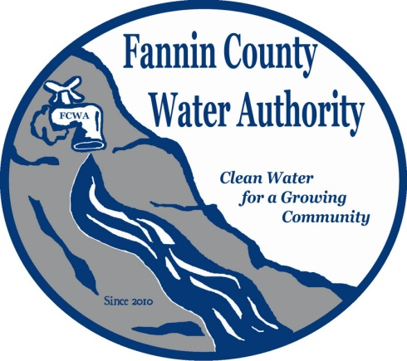
Fannin County Water Authority
Regular Monthly Meeting
Commissioners Meeting Room
January 18, 2017, 2:00 P.M.

Anita Weaver called the meeting to order 2:00 P.M.
Members present were Anita Weaver, Chairwoman, Larry Chapman, Vice-Chairman, Zack Ratcliff, Jackie Self, Larry Atkins and Kay Kendall, Secretary. A quorum was present.
Anita Weaver introduced and welcomed Larry Atkins as a new Board Member.
A motion was made by Zack Ratcliff to approve the minutes from the Regular Monthly Meeting of the Water Authority held December 14, 2016. Kay Kendall seconded the motion. The motion passed unanimously.
Marnie Mashburn, Administrative Assistant reported that collections are being monitored closely with only a couple issues. Anita suggested sending certified letters to two customers. Kay Kendall expressed the need to put a policy in place regarding late fees and disconnections. The Budget vs. Actual report was given to all Board Members. A new request for a water connection was made by David and Betty Brewer at 70 Blue Bird Road in Morganton.
Larry Chapman reported that 300 to 400 feet of pipe is installed on Cold Water Creek Road within Riverwalk on the Toccoa project area. Water samples will be sent for testing and then the water will be made available to the customers. After Cold Water Creek Road is complete, work will continue onto Hunters Ridge.
Larry Atkins reported that a set of rules regarding how and when fees will be billed will be helpful.
Kurt McCord with Carter & Sloope Consulting Engineers reported that Georgia Environmental Protection Division (EPD) is requiring that back-up pumps for all jockey pump stations in the My Mountain Subdivision be installed. There are back-up pumps in storage for this. Once the back-up pumps are installed, it should be as easy as flipping a switch to change pumps. He also reported that EPD has also requested historical water usage information for the customers on these pumps. Marnie is working to supply Carter & Sloope with data for the previous 2 years.
Kurt McCord reported that the Riverwalk on the Toccoa Project is approximately 50% complete. There is a total obligation of $616,000.00 thus far. The projected amount of GEFA monies was $700,000.00 to cover approximately 54 services. The GEFA closing in scheduled for March 1, 2017. A request for an extension will be needed. The FCWA will need to determine if they are sure they would like to de-obligate some of the money that was set aside for the project.
Matt Smith with Carter & Sloope Consulting Engineers reported that the GEFA loan process is yearly with no limitations on how many times an entity can apply. If money is not going to be used, GEFA would like that money returned.
A motion was made by Jackie Self to open a new account to hold Customer Deposits. Zack Ratcliff seconded the motion. The motion passed unanimously.
Marnie Mashburn reported that Cory Suckley at 454 Robert Miller Lane signed a contract for water service, but has decided he does not want the service any longer.
A motion was made by Kay Kendall to null and void the contract with Cory Suckley, but will have to pay full price if he or the subsequent owner needs it in the future. Larry Atkins seconded the motion. The motion passed unanimously.
A motion was made by Kay Kendall to pay Carter & Sloope invoice 21698 in the amount of $11,852.50. Larry Chapman seconded the motion. The motion passed unanimously.
A motion was made by Larry Chapman to pay Carter & Sloope invoice 21697 in the amount of $6,795.00. Kay Kendall seconded the motion. The motion passed unanimously.
A motion was made by Kay Kendall to pay RL Jennings invoice 17053 in the amount of $7,550.00. Larry Chapman seconded the motion. The motion passed unanimously.
A motion was made by Kay Kendall to pay Doss & Associates invoices for services for September, October and November 2016 in the amount of $7,568.75. Zack Ratcliff seconded the motion. The motion passed unanimously.
A motion was made by Kay Kendall to go into Executive Session to discuss real estate. Zack Ratcliff seconded the motion. The motion passed unanimously.
Coming out of executive session, no decisions were made.
A motion was made by Anita Weaver that the meeting adjourns. Zack Ratcliff seconded the motion. The motion passed unanimously.

_______________________________, Anita Weaver, Chairwoman

_______________________________, Kay K. Kendall, Secretary

